Ex. No. : 03 Name: Shreya Amudhu.N.R
Register No. :2116240701505
Application building using Zia assistance
Aim
To develop a Hospital Management System application in Zoho Creator using Zia (AI Assistant) by generating forms, reports, and dashboards through AI-assisted low-code development.

Procedure
- Log in to the Zoho Creator platform.
- Create a new application and launch the Zia AI Assistant.
- Provide prompts describing the Hospital Management System requirements, including modules such as Patient Registration, Appointment Scheduling, Doctor Profile, Bed Allocation, Medical Records, and Doctor Assignment.
- Allow Zia to automatically generate the required forms, reports, and dashboard components.
- Review the generated application structure and make any necessary modifications to field names, layouts, or workflows.
- Test each generated form by entering sample records.
- Verify that the corresponding reports and boards display the entered data correctly.
- Save and publish the completed application.

Screenshots:
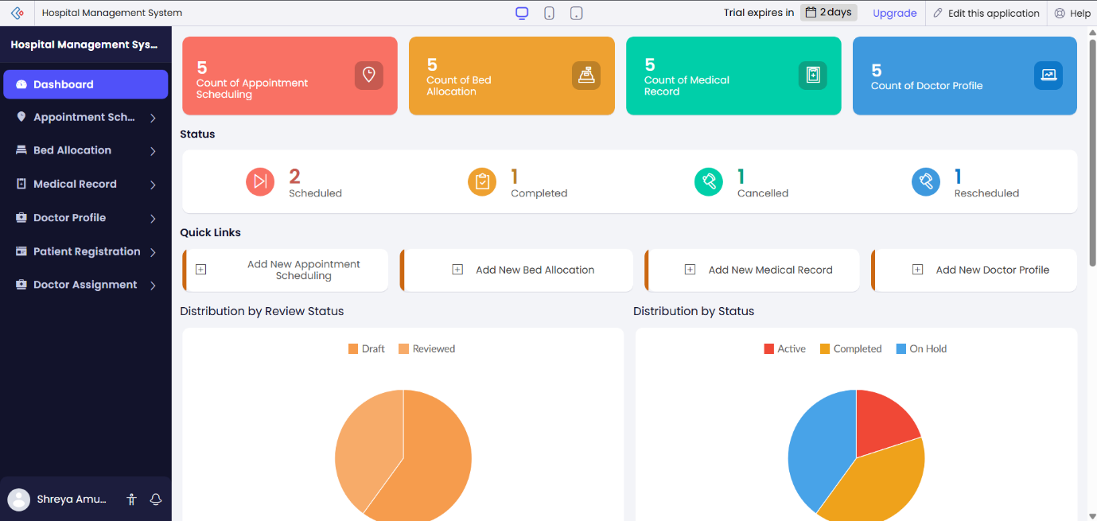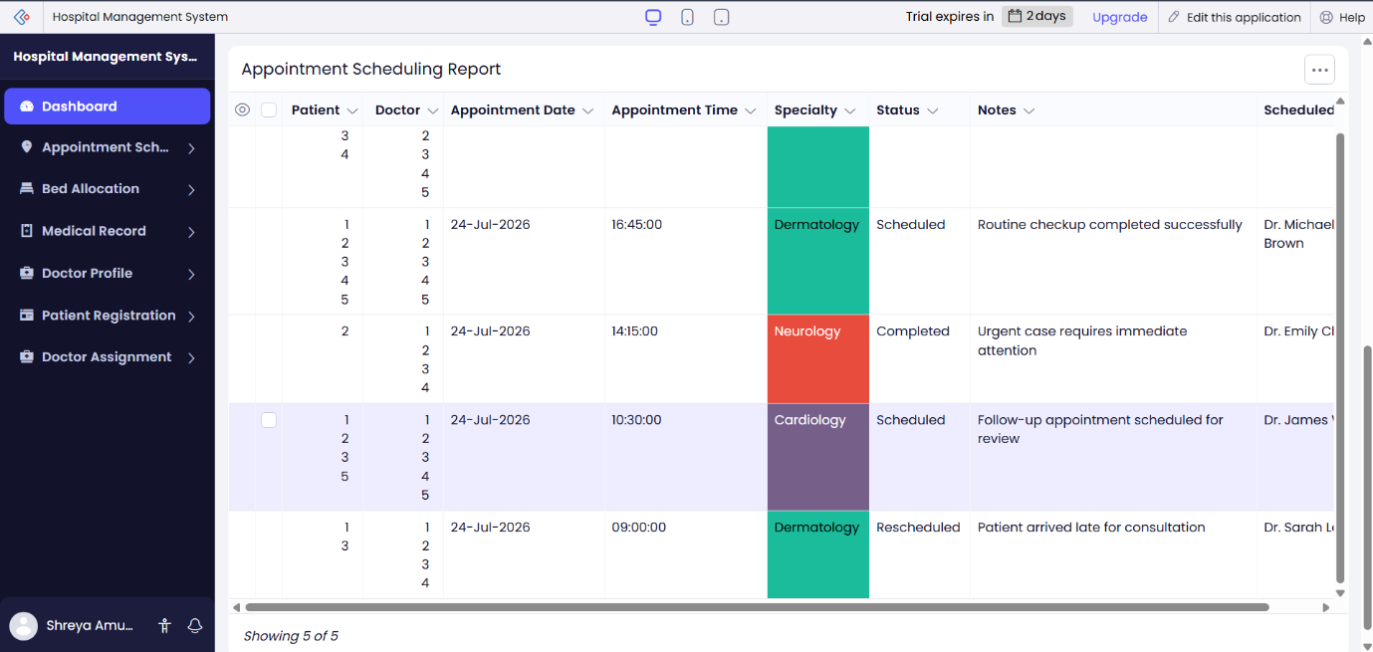
Dashboard

Appointment Scheduling:
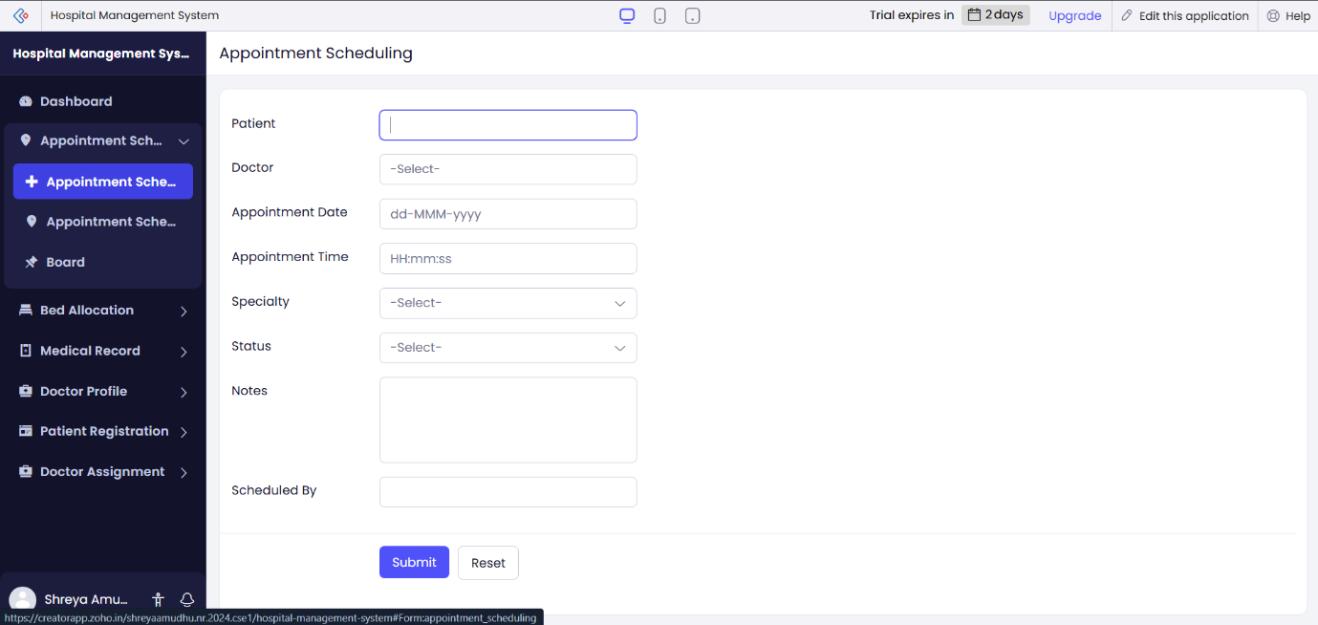
Appointment Scheduling Form
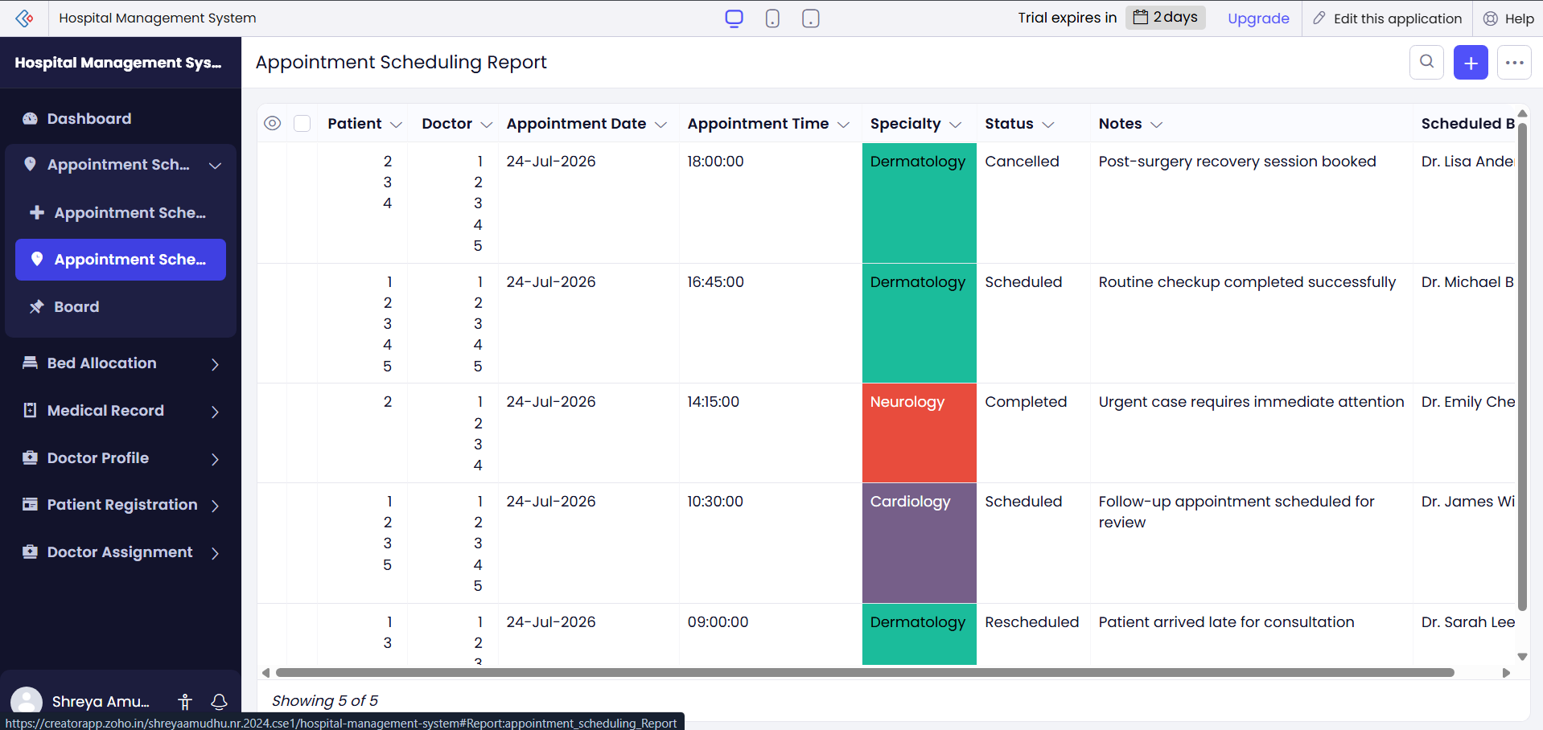
Appointment Scheduling Report
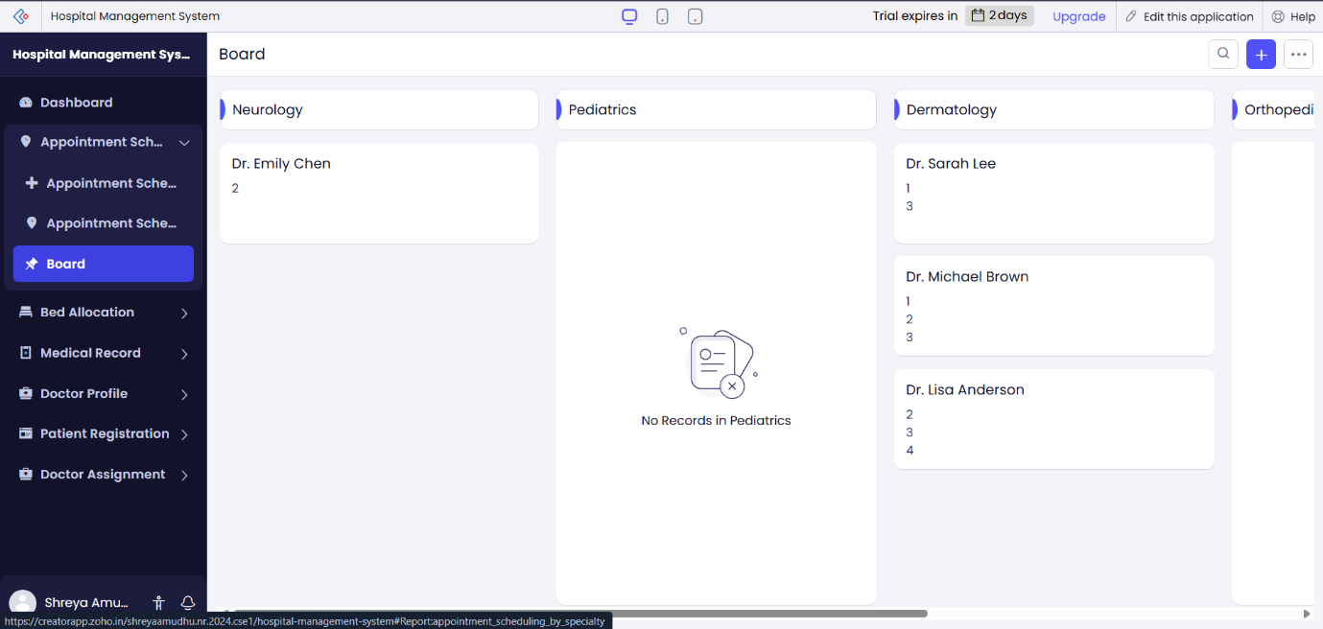
Appointment Scheduling Board

Bed Allocation:
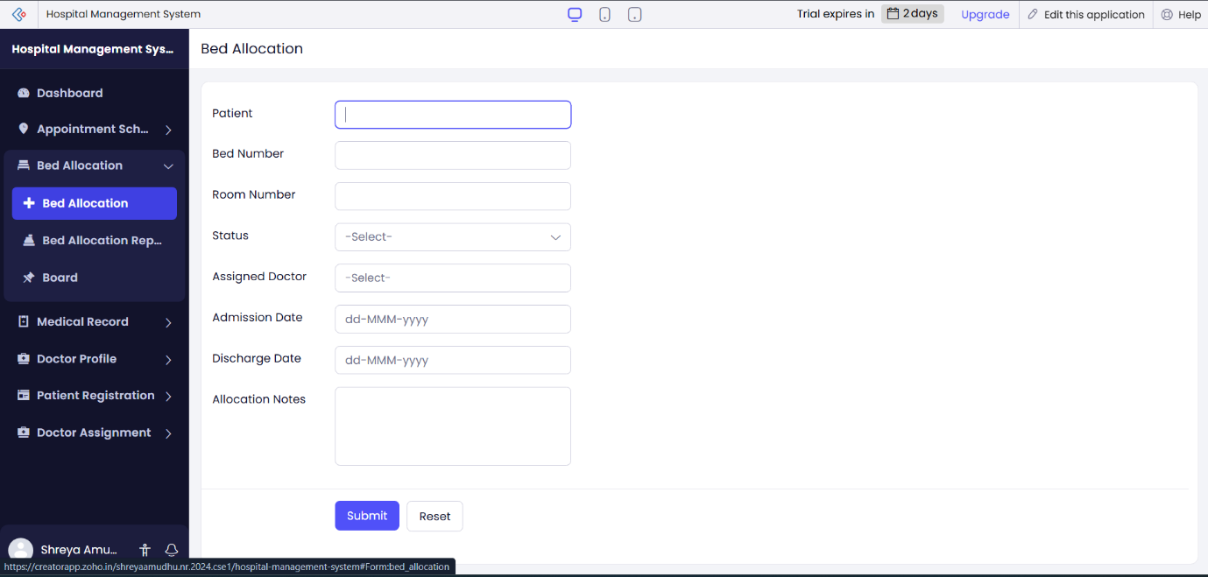
Bed Allocation Form
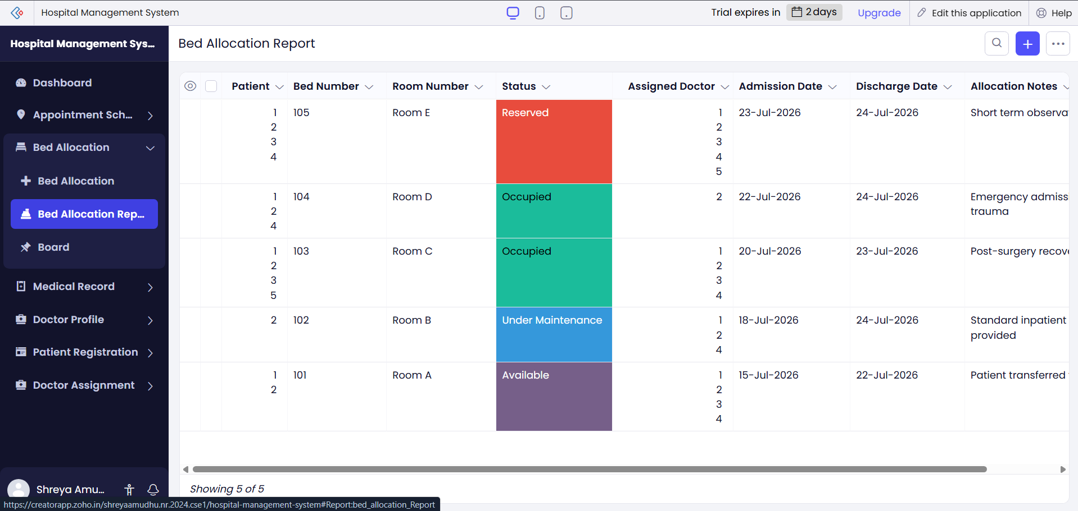
Bed Allocation Report

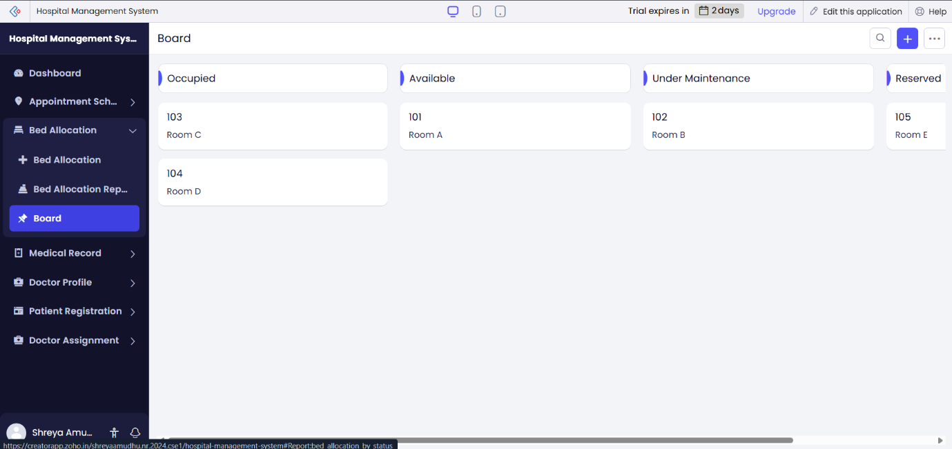
Bed Allocation Board

Medical Records:
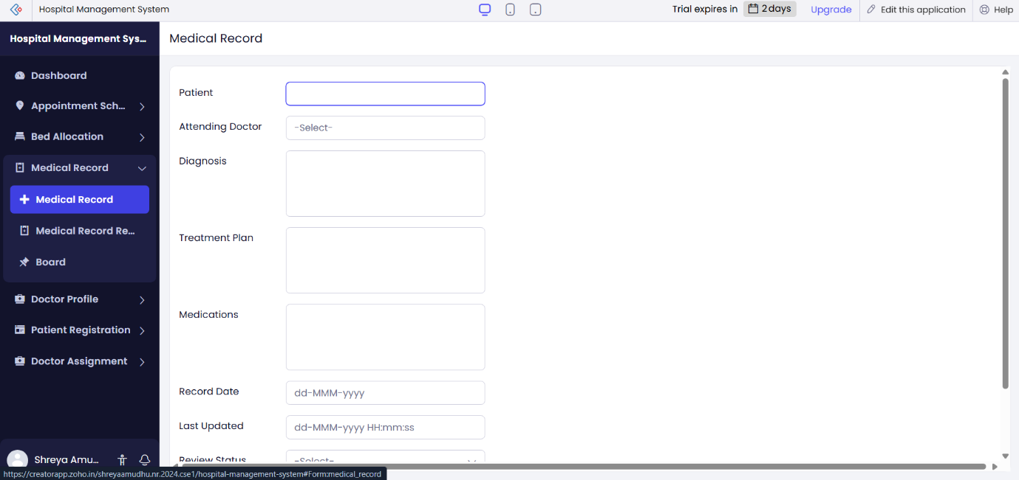
Medical Records Form

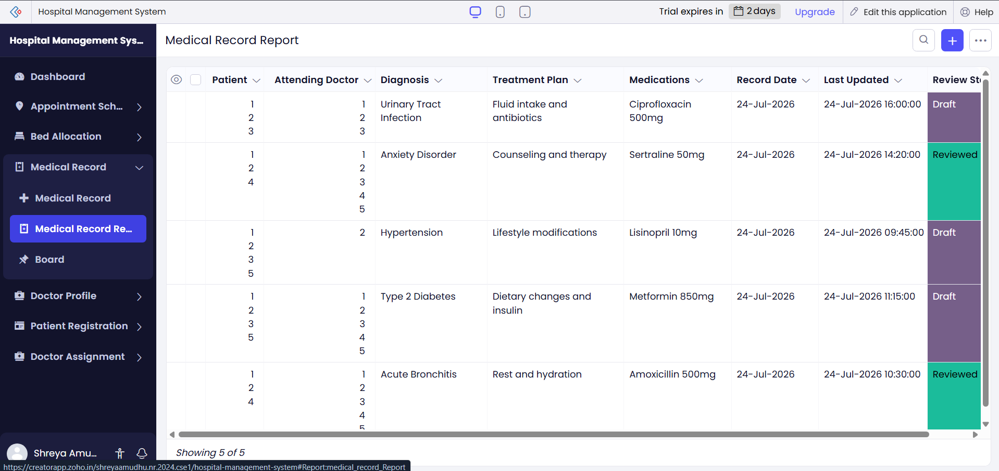
Medical Records Report
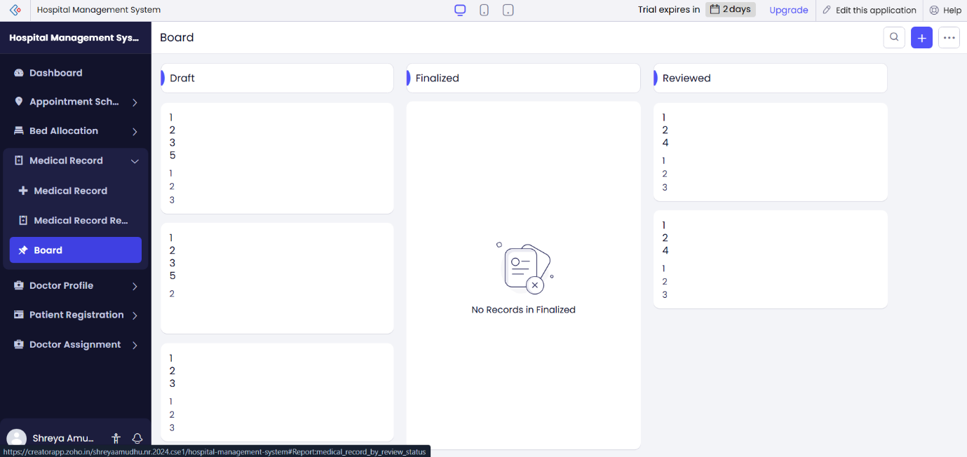
Medical Records Board

Doctor Profile:
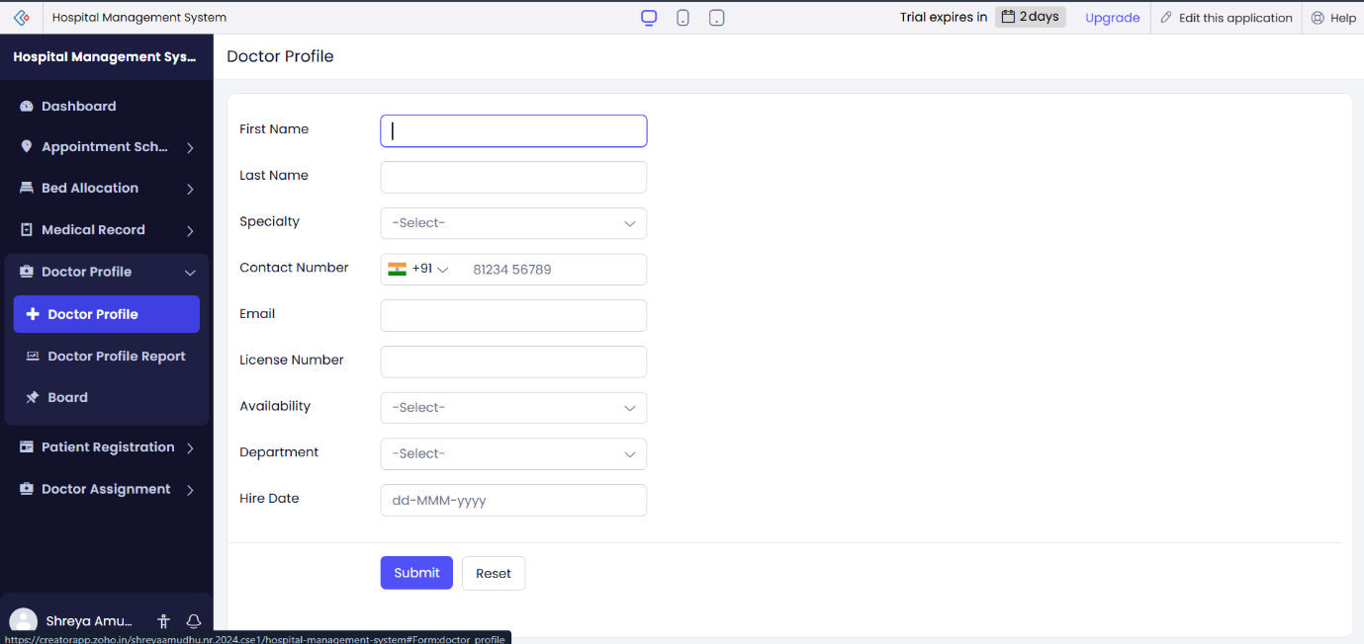
Doctor Profile Form
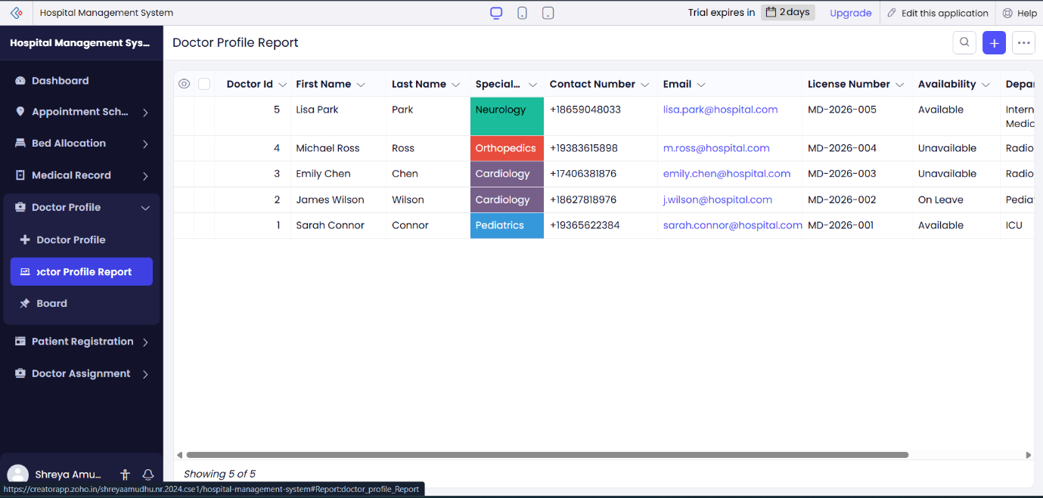
Doctor Profile Report

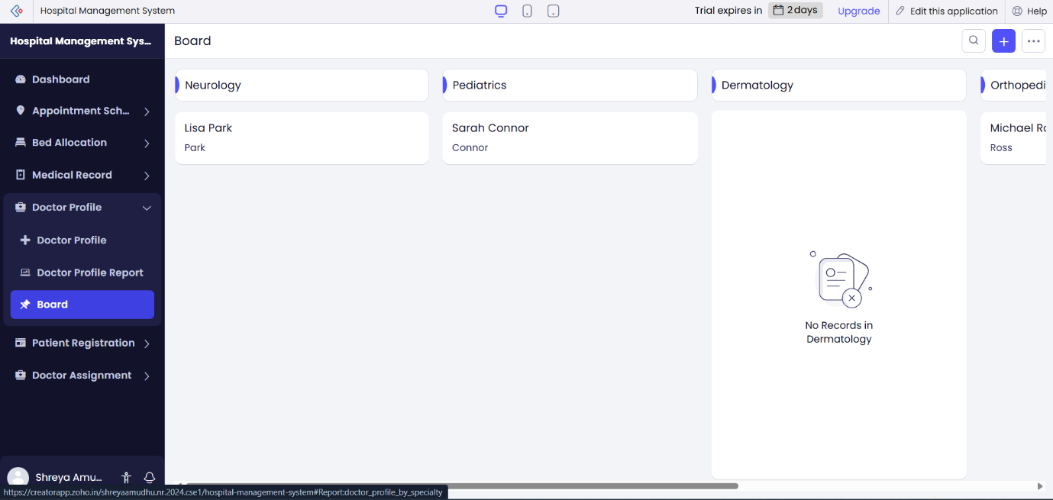
Doctor Profile Board

Patient Registration:
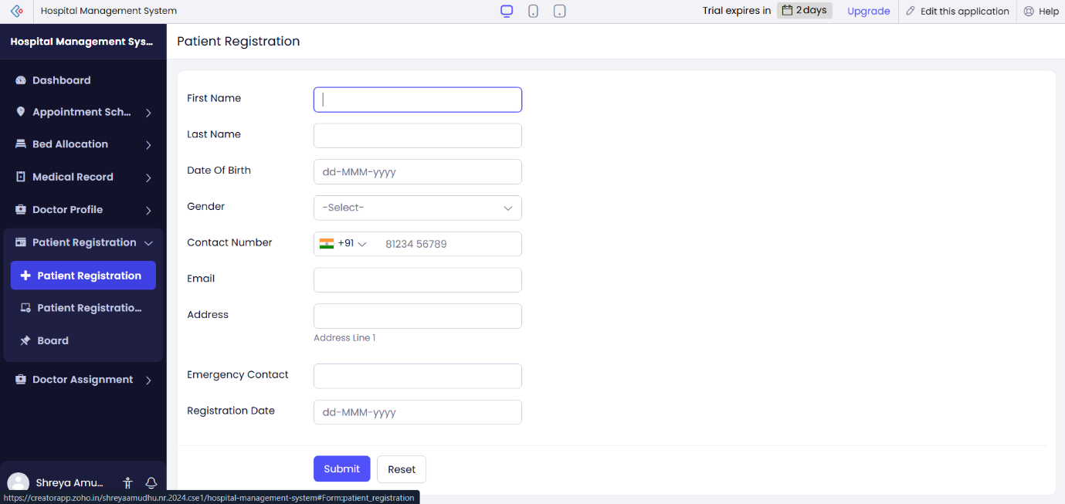
Patient Registration Form

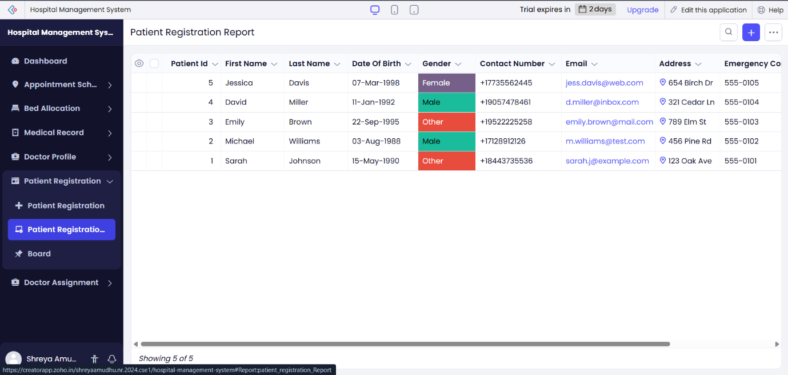
Patient Registration Report
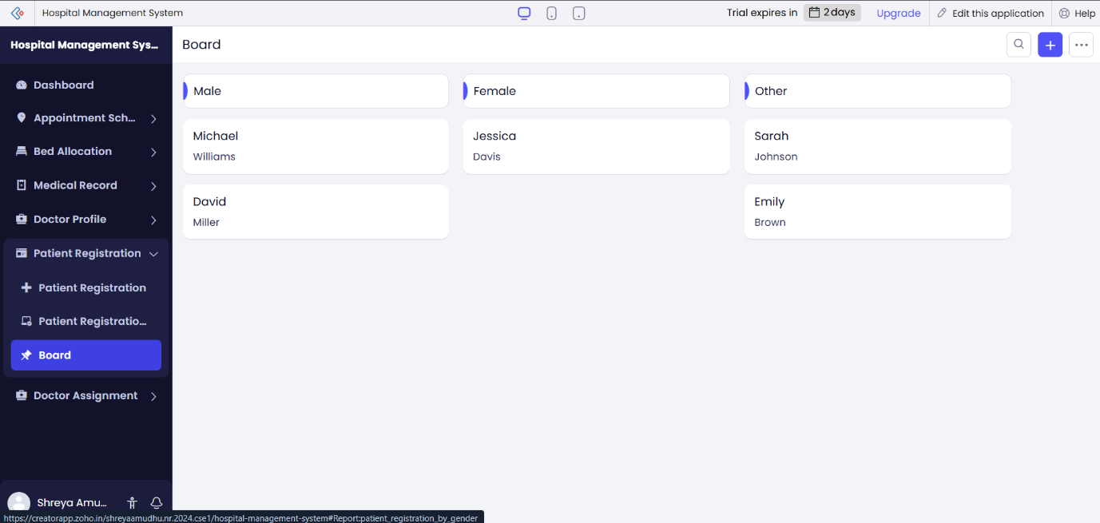
Patient Registration Board

Doctor Assignment:
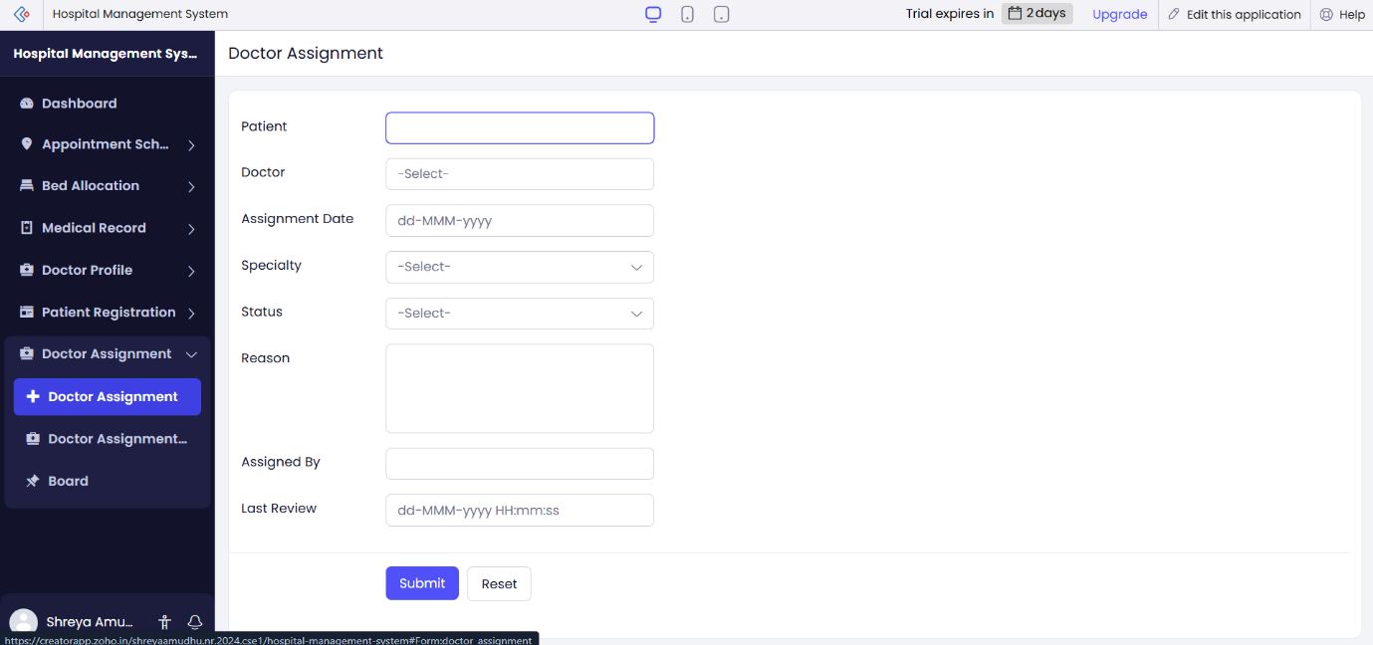
Doctor Assignment Form
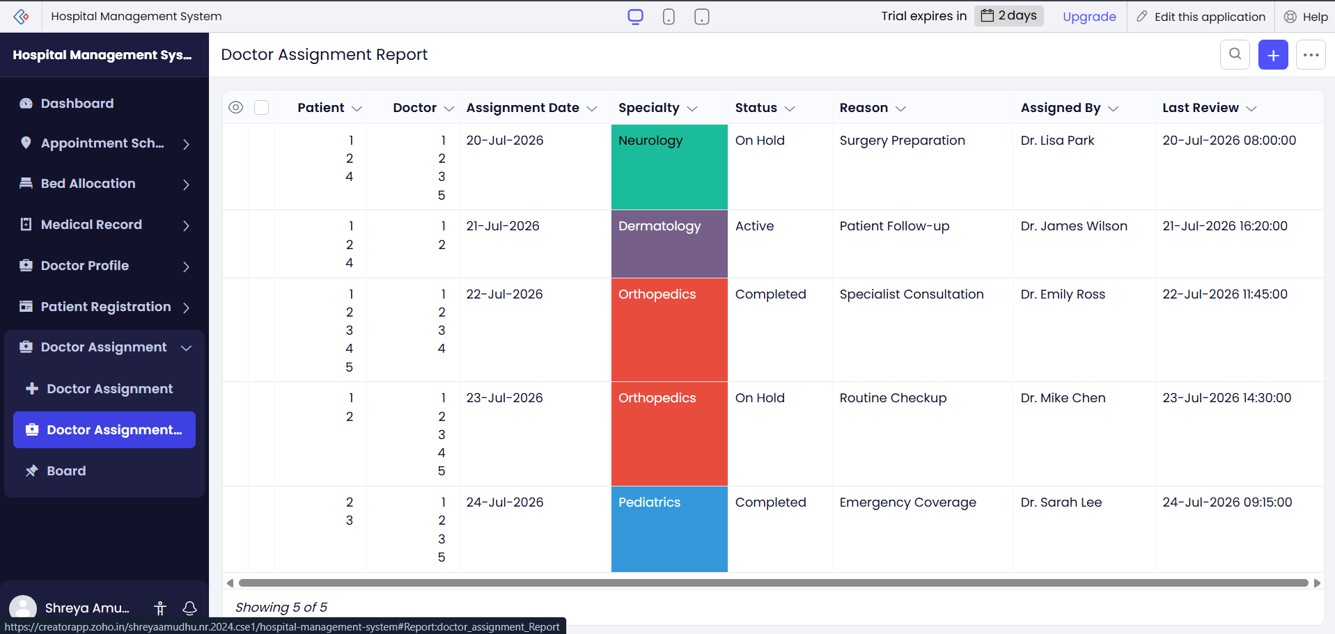
Doctor Assignment Report

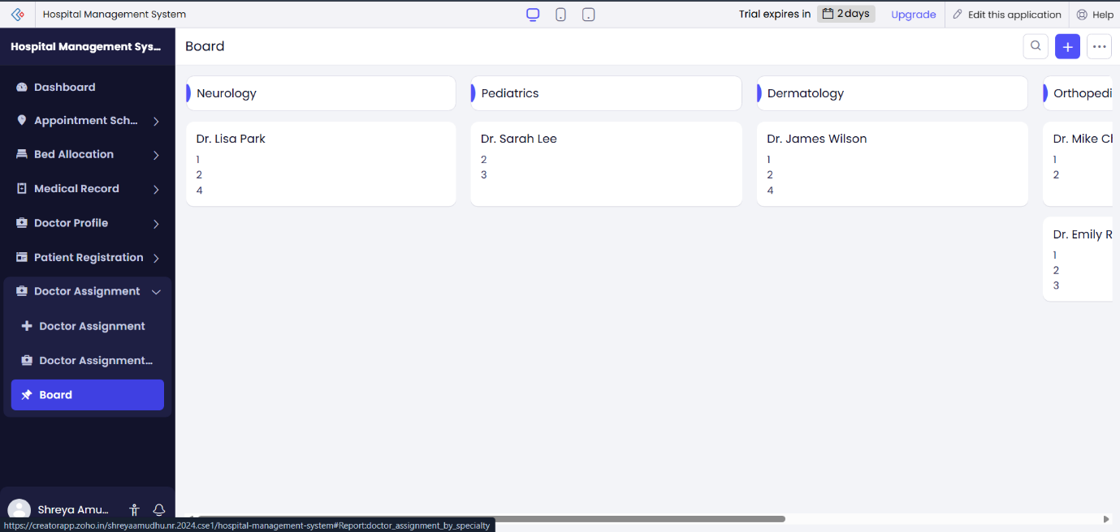
Doctor Assignment Board

Result
The application was successfully created in Zoho Creator using Zia AI Assistant. The required forms, reports, dashboards, and other application components were generated and configured successfully, demonstrating the efficiency of AI-assisted low-code application development in rapidly building functional business applications.

